IDEATION PHASE
BRAINSTORM & IDEA PRIORITIZATION TEMPLATE

Date | FEB 2026
Team ID | LTVIP2026TMIDS37677
Project Name | ToyCraft tales: tableau's vision into toy manufacturer data
Maximum Marks | 4 Marks

Step-1: Team Gathering, collaboration and select the problem statement

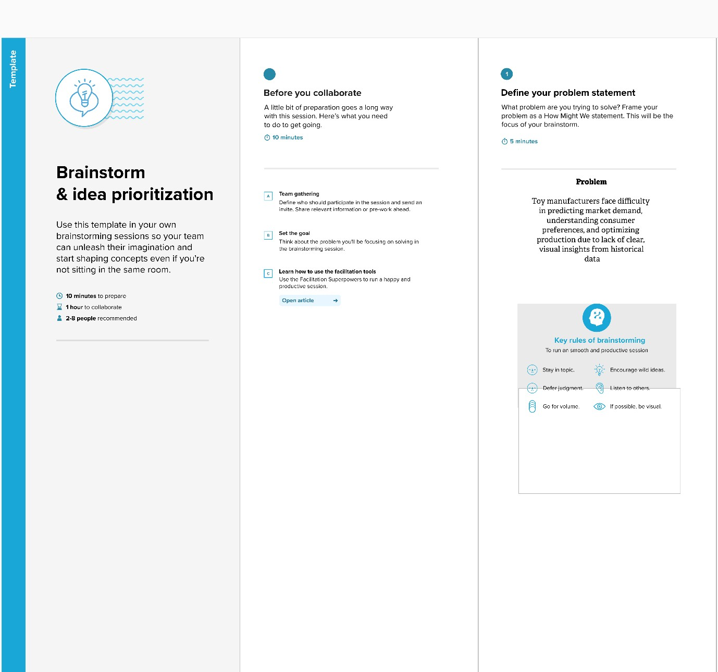

Step-2: Brainstorm, Idea Listing and Grouping

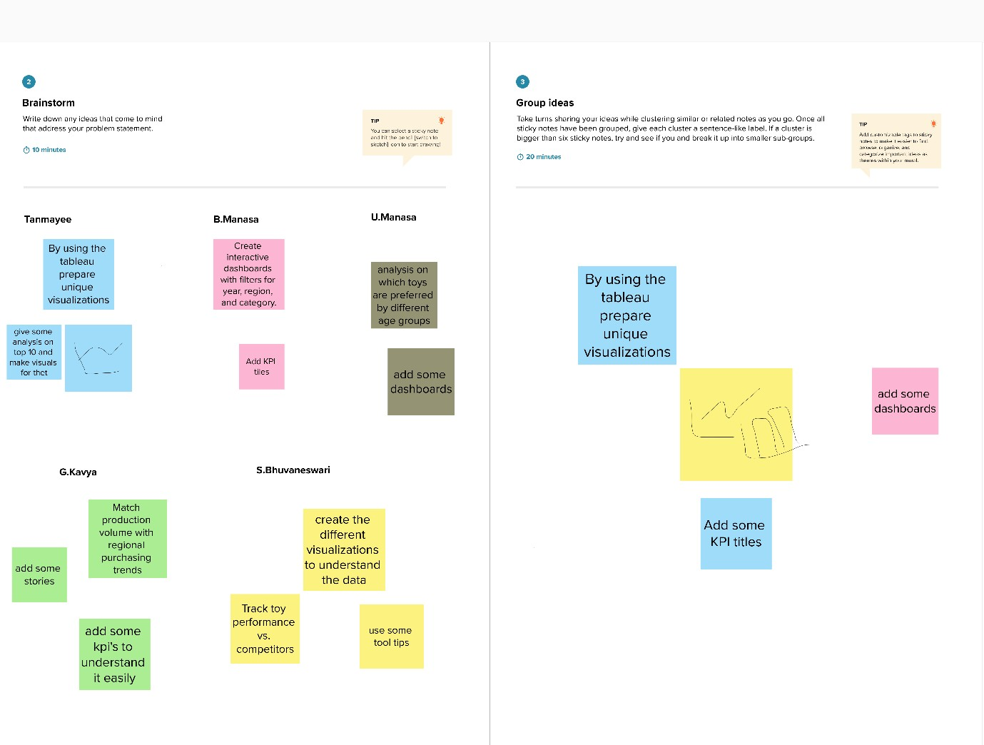

Step-3: Idea prioritization

